Basic Concepts

There are certain services and models working behind the scene making the cloud computing feasible and accessible to end users. Following are the working models for cloud computing:

* Deployment Models
* Service Models

Deployment Models

Deployment models define the type of access to the cloud, i.e., how the cloud is located? Cloud can have any of the four types of access: Public, Private, Hybrid, and Community.

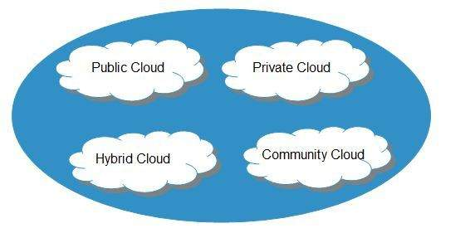

Public Cloud

The **public cloud** allows systems and services to be easily accessible to the general public. Public cloud may be less secure because of its openness.

Private Cloud

The **private cloud** allows systems and services to be accessible within an organization. It is more secured because of its private nature.

Community Cloud

The **community cloud** allows systems and services to be accessible by a group of organizations.

Hybrid Cloud

The **hybrid cloud** is a mixture of public and private cloud, in which the critical activities are performed using private cloud while the non-critical activities are performed using public cloud.

Service Models

Cloud computing is based on service models. These are categorized into 4 basic service models which are -

* Infrastructure-as–a-Service (IaaS)
* Platform-as-a-Service (PaaS)
* Software-as-a-Service (SaaS)
* Network as–a –services
* **Anything-as-a-Service (XaaS)** is yet another service model, which includes , Business-as-a-Service, Identity-as-a-Service, Database-as-a-Service or Strategy-as-a-Service.

The **Infrastructure-as-a-Service (IaaS)** is the most basic level of service. Each of the service models inherit the security and management mechanism from the underlying model, as shown in the following diagram:

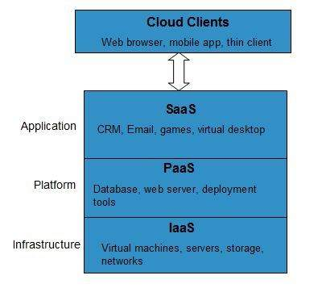

Infrastructure-as-a-Service (IaaS)

**IaaS** provides access to fundamental resources such as physical machines, virtual machines, virtual storage, etc.

Platform-as-a-Service (PaaS)

**PaaS** provides the runtime environment for applications, development and deployment tools, etc.

Software-as-a-Service (SaaS)

**SaaS** model allows to use software applications as a service to end-users.

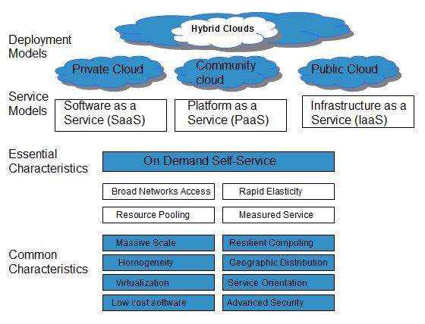

On Demand Self Service

Cloud Computing allows the users to use web services and resources on demand. One can logon to a website at any time and use them.

Broad Network Access

Since cloud computing is completely web based, it can be accessed from anywhere and at any time.

Resource Pooling

Cloud computing allows multiple tenants to share a pool of resources. One can share single physical instance of hardware, database and basic infrastructure.

Rapid Elasticity

It is very easy to scale the resources vertically or horizontally at any time. Scaling of resources means the ability of resources to deal with increasing or decreasing demand.

The resources being used by customers at any given point of time are automatically monitored.

Measured Service

In this service cloud provider controls and monitors all the aspects of cloud service. Resource optimization, billing, and capacity planning etc. depend on it.